1. In this lesson, we are going to look at the way we can expedite the creation of a maven project.
2. We know that we can build our directory structure manually that conforms the standard directory layout and we can put pom.xml file within our project. And we can do all with file system pretty much.
3. But there is a maven plug-in that can really increase the way you create your project.
4. The name of the plug-in is **archetype** and the goal is **generate**   
   Command 🡺 mvn **archetype:generate**
5. 
6. When you run this command, maven goes out, grab the archetypes (predefined projects. They are template you can use to create your own project). 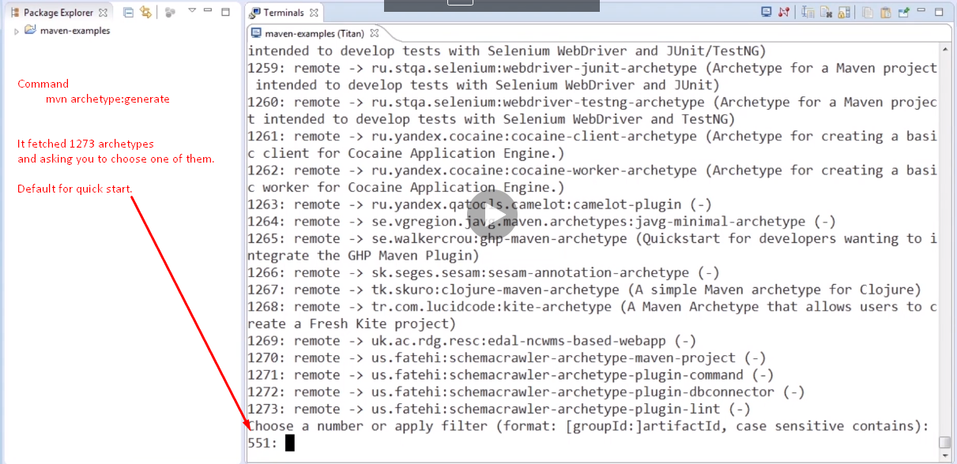
7. 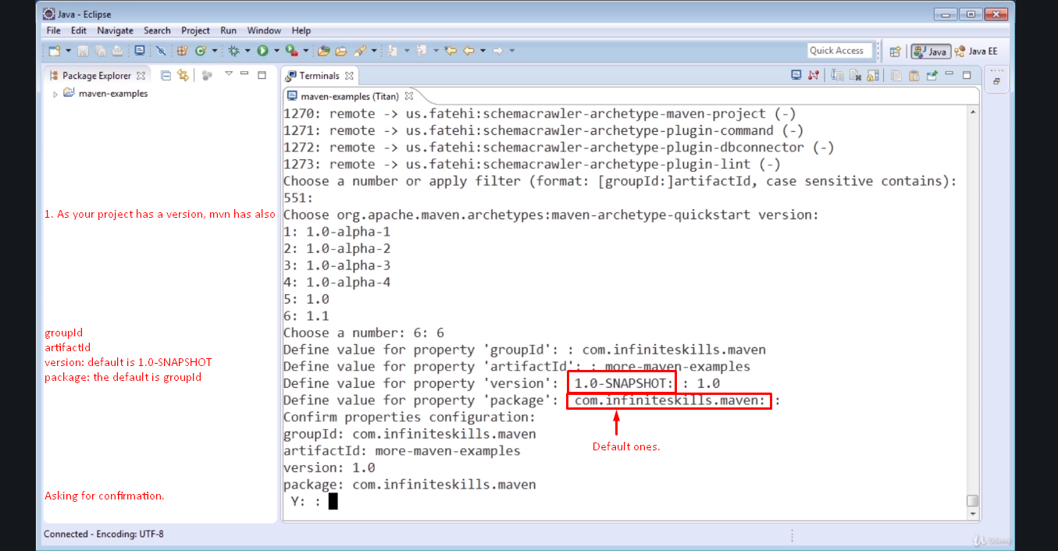 
8. Now convert the maven project into eclipse project with command 🡺 mvn eclipse:eclipse so that we can import it with the following option.
9. Then import the project:  
   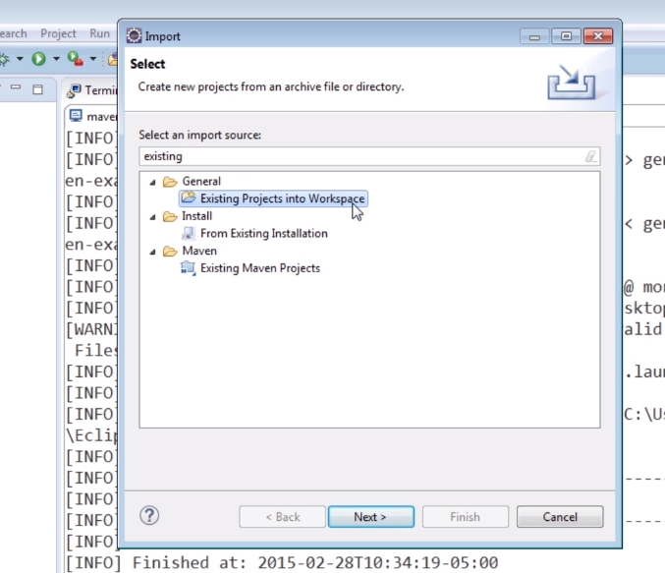

**Existing Projects into Workspace also works.**